

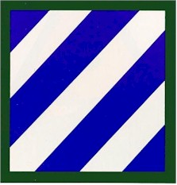 | Shoulder Sleeve Insignia  Description: Upon a blue square three white stripes from heraldic sinister chief to dexter base, the blue background between the white stripes, all within a green border.  Symbolism: The three white stripes are symbolic of six campaigns  (formerly referred to as three major operations) in which the division participated in World War 1. The blue field symbolizes the loyalty of those who placed their lives on the altar of self-sacrifice in defense of the American ideals of liberty and democracy.
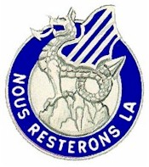 | Distinctive Unit Insignia  Description: A silver colored metal and enamel device, consisting of a silver rock issuing from the inner arc of a blue annulet inscribed with the words "NOUS RESTERONS LA" (We Will Stay There) in silver letters; on the rock and surmounting the upper part of the annulet, a silver wyvern winged blue bearing thereon three silver diagonal bands.  Symbolism: The rock, inscription, and wyvern refer to the two desig-  nations by which men of the 3d Infantry Division are popularly known, i.e., "Marne Men" and "Blue and White Devils." The rock represents the division's firm stand against the German offensive at the Marne River  in World War I. It was there that the commanding officer, Major General Joseph Dickman, stated "Nous Resterons LA." The wyvern, an heraldic form of the devil, bears the division's blue and white stripes on its wing in commemoration of the division's action at Anzio, Italy, in World War II where they were called "Blue and White Devils" by the enemy.

